COIT13230: Application Development Project

Term 2, 2026

Assessment 1 – Group Project Proposal

Student names:
Matthew Haydon – 12232615
Farhad Azim – 12284745

Course Coordinator: Farzad Sanati

Contents
Project Background and Justification 3
Problem Statement and Project Objectives 4
Problem Statement 4
Project Objectives 4
Innovative Aspects 6
Project Scope 8
In scope 8
Out of scope 8
Assumptions and Constraints 9
Assumptions 9
Constraints 9
System Design 10
Use Case Diagram 10
Subsystems 11
External Entities 11
Context Diagram 11
High-Level Requirements Overview 12
Functional Requirements 12
Nonfunctional Requirements 12
Software Components 13
Work Decomposition 14
Work Breakdown Structure 15
Delivery Roadmap 16
Risk Identification and Mitigation Plan 17

Project Background and Justification
The current landscape of health and wellness applications reveals a significant gap in highly adaptable and user-centric nutritional tools. Below are the detailed context and justification for developing the “AI-Based Smart Meal Planner”:
- The Modern Nutritional Challenge: Managing complex commitments alongside physically or mentally demanding jobs leaves individuals with minimal time for effective meal planning. For example, a person maintaining a highly active routine, such as walking up to 30,000 steps during a prolonged retail shift, requires highly specific caloric and macronutrient refill. Generic meal-planning applications offer static solutions that fail to address these extreme variations in daily energy expenditure.
Justification: The proposed application addresses this by providing personalised meal recommendations based directly on the user's specific health goals. This tailored approach allows the application to adapt to dynamic, real-world physical demands rather than forcing the user into a generic dietary template.
- Mitigating Food Waste and Budget Inefficiencies: Traditional meal planners dictate what a user should eat without considering the things they have in-hand. This oversight forces unnecessary trips to the supermarket, inflates weekly grocery budgets, and directly contributes to household food waste.
Justification: By explicitly generating meal plans and recipes based on the available ingredients supplied by the user, the application provides a highly practical and economically viable solution. This justifies the system's design as a tool not just for health, but for efficient household management.
- The Need for Dynamic, AI-Driven Solutions: Existing applications rely on hard-coded databases. If a user has a strict dietary restriction (e.g., vegan) combined with a limited set of random ingredients, a static database will most likely return zero recipe results.
Justification: The integration of Generative AI completely bypasses the limitations of static databases. Generative AI will be incorporated to support the generation of personalised weekly meal plans and recipes, justifying the project's technological complexity by offering infinite, dynamic meal combinations that specifically fit the user's exact constraints.
- Mobile-First Accessibility: Meal planning and grocery shopping are inherently mobile activities. Users require immediate, on-the-go access to their dietary requirements, generated recipes, and shopping lists while actively navigating a store.
Justification: The scope of this project is explicitly to design and develop a prototype smart meal planning application for Android devices. Delivering this as an Android prototype justifies the mobile-first approach, ensuring users can access automatically created and categorised grocery lists precisely when and where they need them.

Problem Statement and Project Objectives
To clearly define the scope and intent of the AI-Based Smart Meal Planner, the core issues being addressed and the specific targets of the system are outlined below:

Problem Statement
- The Burden of Manual Planning: Users consistently struggle to maintain specific dietary and health goals because manual meal planning introduces a high cognitive load. Researching and scheduling a full week of meals is a time-consuming process that often leads to user burnout and abandonment of diet plans.
- Rigidity of Dietary Constraints: Finding recipes that accommodate strict dietary restrictions (such as vegan or gluten-free), align with precise caloric targets, and utilize on-hand ingredients is an overwhelmingly difficult and frustrating process when using traditional, static recipe databases.
- Inefficient Grocery Mapping: Translating an incoherent list of recipes into an actionable, efficient grocery shopping list is a manual task that frequently results in forgotten ingredients, duplicate purchases, and extended trips to the supermarket.

Project Objectives
The primary aim of this project is to completely automate the discovery, scheduling, and logistical planning of weekly meals. The specific, actionable objectives include:
Objective 1: Develop a Tailored Android Prototype
- Action: Design and develop a prototype smart meal planning application specifically for Android devices.
Justification: This ensures the application is highly accessible on mobile platforms. It guarantees the system provides personalised meal recommendations based on information supplied by the user, creating a user-centric experience rather than a generic one.
Objective 2: Integrate Generative AI for Dynamic Planning
- Action: Generative AI will be incorporated into the application to support the generation of personalised weekly meal plans and recipes.
Justification: This directly solves the problem of rigid dietary constraints. By utilizing an AI API, the system can dynamically consider complex, overlapping factors including the user's health goals, dietary restrictions, food preferences and available ingredients.

Objective 3: Provide Comprehensive Nutritional Transparency
- Action: Ensure the calculation and presentation of calorie, macronutrient and micronutrient information for every generated meal.
Justification: Users cannot achieve specific health and weight goals without accurate metrics. Providing detailed nutritional information for generated meals enables the user to track their exact intake and ensures the AI's suggestions safely align with their physiological needs.
Objective 4: Automate and Optimise Grocery Logistics
- Action: Develop a subsystem to automatically create categorised grocery lists based on the ingredients required by the user's meal plan.
Justification: This addresses the inefficiency and frustration of using manual shopping lists. By ensuring the categorisation of grocery list items into relevant groups such as produce, pantry and protein.

Innovative Aspects
The AI-Based Smart Meal Planner differentiates itself from existing market solutions by utilizing modern artificial intelligence to solve complex logistical and nutritional problems. Below are the specific innovative features and their justifications:
- Dynamic Recipe Generation and Intelligent Substitution: Generative AI will be incorporated into the application to support the generation of personalised weekly meal plans and recipes. The system is also designed to provide suggestions for alternative ingredients where appropriate.
Justification: Traditional apps rely on hard-coded recipe databases. If a user is missing a single ingredient, the recipe often becomes useless. This innovative use of Generative AI ensures the application dynamically adapts to the user's immediate reality. By actively suggesting substitutions based on the entry of ingredients currently available to the user, the application eliminates the need for emergency supermarket trips and reduces household food waste.
- Highly Contextual and Adaptive Nutritional Alignment: The application will consider factors including the user's health goals, dietary restrictions, food preferences and available ingredients when generating meal plans and recipes. To support this, it performs the calculation and presentation of calorie and micronutrient information.
Justification: Standard meal planners offer rigid dietary templates that fail to account for unique physical demands. This AI-driven approach allows the system to intelligently adjust recommendations for users maintaining highly active routines. It dynamically calculates exact nutritional needs to ensure the creation and management of a user profile containing health and weight goals is continuously supported by the generated meals.
- Retail-Optimized Grocery Categorisation: The system will automatically create categorised grocery lists based on the ingredients required by the user's meal plan. This involves the categorisation of grocery list items into relevant groups such as produce, pantry and protein.
Justification: Most applications simply output a chronological or alphabetical list of required items, forcing users to zigzag across a store. This innovative feature practically aligns the software with real-world retail environments. By sorting items into standard supermarket groups, the output naturally mimics the physical aisle layout. This structural innovation transforms a basic list into a highly efficient shopping map, saving users significant time and frustration.
- Complete Integration into a Single Mobile Interface: The project focuses heavily on delivering a mobile user interface that allows users to access and interact with the application's primary functions, ensuring seamless storage and retrieval of user profiles, meal plans, recipes and grocery lists.
Justification: While users can technically use standard LLM web interfaces (like ChatGPT) to ask for recipes, doing so requires manual prompt engineering, external nutritional calculators, and manual transcription into a separate notes app for shopping. The innovation here lies in system integration. The application combines complex AI prompting, nutritional dataset querying, and list management into a single, cohesive Android application interface, completely removing the technical conflict for the end-user.

Project Scope
The scope of this project is to design and develop a prototype smart meal planning application for Android devices that provides personalised meal recommendations based on information supplied by the user. The application will consider factors including the user's health goals, dietary restrictions, food preferences and available ingredients when generating meal plans and recipes.
Generative AI will be incorporated into the application to support the generation of personalised weekly meal plans and recipes. The system will also provide nutritional information for generated meals and automatically create categorised grocery lists based on the ingredients required by the user's meal plan.

In scope
The project will include:
- Creation and management of a user profile containing health and weight goals, dietary requirements and food preferences.
- Entry of ingredients currently available to the user.
- Generation of personalised weekly meal plans using Generative AI.
- Generation of recipes based on user preferences, restrictions and available ingredients.
- Suggestions for alternative ingredients where appropriate.
- Calculation and presentation of calorie, macronutrient and micronutrient information.
- Automatic generation of grocery lists from generated meal plans and recipes.
- Categorisation of grocery list items into relevant groups such as produce, pantry and protein.
- Storage and retrieval of user profiles, meal plans, recipes and grocery lists.
- A mobile user interface that allows users to access and interact with the application's primary functions.

Out of scope
To maintain a realistic project within the available development period, the prototype will not include:
- Replacement of professional medical or nutritional advice.
- Direct ordering or purchasing of groceries through supermarkets.
- Integration with wearable health or fitness devices.
- Real-time monitoring of a user's physical health.
- Development of a custom Generative AI model.
- Development of a custom nutritional dataset.
- Consider the financial cost of ingredients or produce.

Assumptions and Constraints

Assumptions
The development of the proposed application is based on several assumptions that influence the development and functionality of the project.
- Generative AI availability: It is assumed that the selected Generative AI service will remain accessible throughout the development and testing of the application. The meal plan and recipe generation components depend on access to this service.
- Nutrition data availability: It is assumed that an accurate public nutrition dataset will be available to provide the nutritional values required by the Nutrition Analysis component.
- Accurate user information: The application assumes that users provide accurate information regarding their health goals, dietary restrictions, preferences and available ingredients. The relevance of generated results will depend on the accuracy of these inputs.
- Internet connectivity: It is assumed that users will have an active internet connection when accessing functionality that requires communication with external services, particularly the Generative AI service.

Constraints
Several constraints affect the scope and implementation of the proposed application.
- Development timeframe: The project must be completed within the allocated timeframe. This limits the number and complexity of features that can be designed, implemented and tested.
- Team size: Development will be completed by a team of two. Tasks must therefore be appropriately distributed to ensure that development, testing, documentation and project management activities can be completed within the available timeframe.
- Development knowledge and tools: The project will primarily use technologies and techniques developed through previous study.
- Dataset limitations: The size and coverage of nutrition data available to the prototype may be limited. Therefore, the nutritional analysis will depend on the ingredients and nutritional information available within the selected dataset.
- Platform limitation: The prototype will be developed specifically for Android devices using Android Studio. Development and testing for other mobile platforms, such as iOS, are outside the scope of the current project.
- External service dependency: AI functionality will depend on the availability and limitations of the selected external Generative AI service. Service availability, usage limits or changes to the service may affect application functionality.

System Design
The system design identifies the major interactions, subsystems, external entities and software components required to implement the proposed smart meal planning application. The design is based on the primary functionality expected by users and separates this functionality into individual system components.
The application is structured around several connected areas of functionality: user profile management, AI-assisted meal plan generation, AI-assisted recipe generation, nutritional analysis, grocery list generation, data storage and the Android application interface.

Use Case Diagram
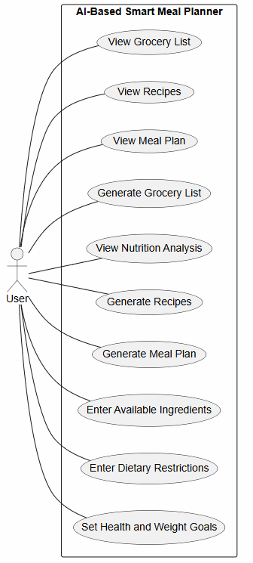
This use case diagram shows the main interactions between the user and the AI-Based Smart Meal Planner. The user can enter their health and weight goals, dietary restrictions and available ingredients, which are used to generate personalised meal plans and recipes. The user can also view nutritional information and generate grocery lists based on their meal plan.

Subsystems
- User Profile Manager: Handles health and weight goals, dietary requirements, preferences and available ingredients.
- Meal Plan Generator (AI): Generates personalised weekly meal plans using information from the user profile.
- Recipe Generator (AI): Generates recipes based on meal plans, dietary requirements and available ingredients, including alternative ingredient suggestions.
- Nutrition Analysis Engine: Calculates and provides calorie, macronutrient and micronutrient information.
- Grocery List Generator: Creates categorised grocery lists based on generated meal plans and recipes.
- Data Storage / Database: Stores user profile information, available ingredients, generated meal plans, recipes and grocery lists.
- Mobile App Interface: Provides the Android interface used by the user to enter information and access generated results.

External Entities
- User: Provides health goals, dietary requirements and available ingredients, and accesses generated results.
- GenAI API: External AI service used to generate meal plans and recipes.
- Public Nutrition Dataset: Provides nutritional information used by the Nutrition Analysis Engine.

Context Diagram
The context diagram shows the interaction between the AI-Based Smart Meal Planner System and its external entities. The user provides health and weight goals, dietary requirements and available ingredients, while the system returns generated meal plans, recipes, nutrition information and grocery lists. The system also communicates with a GenAI API for meal and recipe generation and a public nutrition dataset for nutritional information.
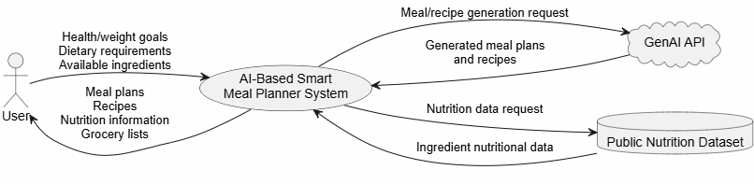

High-Level Requirements Overview
The following functional and non-functional requirements define the main functionality and quality expectations of the AI-Based Smart Meal Planner.

Functional Requirements
- The system shall allow users to enter and update information required for personalised meal planning.
- The system shall allow users to set health and weight goals, such as weight loss, maintenance or weight gain.
- The system shall allow users to enter dietary requirements and restrictions.
- The system shall allow users to enter available ingredients.
- The system shall generate personalised weekly meal plans based on the user's goals, dietary requirements and available ingredients.
- The system shall generate recipes based on the user's meal plan, dietary requirements and available ingredients.
- The system shall suggest alternative ingredients where appropriate.
- The system shall provide calorie and nutritional information for generated meals.
- The system shall provide macronutrient and micronutrient information.
- The system shall generate a grocery list based on the generated meal plan and recipes.
- The system shall categorise grocery list items into relevant groups.
- The system shall allow users to view generated meal plans, recipes, nutritional information and grocery lists.

Nonfunctional Requirements
- The application should respond to user interactions within a reasonable amount of time during normal use.
- User information, including health goals and dietary requirements, must be handled and stored securely.
- The application should handle errors or unavailable external services without unexpectedly crashing.
- Generated meal plans and recipes should follow the dietary requirements and restrictions provided by the user.
- The application should provide a simple and consistent interface that allows users to easily access its main features.
- The application must operate on compatible Android devices and be developed and tested using Android Studio.
- User information, meal plans, recipes and grocery lists should be stored and retrieved accurately.

Software Components
The identified requirements and subsystems have been separated into the following software components, with each component responsible for a specific area of the application.
Software Component | Purpose | Key Responsibilities
User Profile Component | Manages information used to personalise meal plans. | Stores health and weight goals, dietary requirements and available ingredients; validates user input.
Meal Plan Generator Component (AI) | Generates personalised weekly meal plans. | Sends relevant user information to the GenAI service; receives and formats generated meal plans.
Recipe Generator Component (AI) | Generates recipes that match user requirements. | Generates recipes based on meal plans, dietary requirements and available ingredients; provides alternative ingredient suggestions.
Nutrition Analysis Component | Provides nutritional information for meals and recipes. | Retrieves nutrition data and provides calorie, macronutrient and micronutrient information.
Grocery List Component | Creates grocery lists from generated meals and recipes. | Identifies required ingredients and organises them into categories such as produce, pantry and protein.
Data Storage Component | Stores application data. | Stores and retrieves user information, meal plans, recipes and grocery lists.
Android Application Interface | Provides the user-facing Android interface. | Handles user input, displays generated information and provides navigation between application features.

Work Decomposition
The project has been decomposed into major deliverables and related tasks to provide a clear structure for planning, development and project management. Each work package represents a significant component required for the successful completion of the AI-Based Smart Meal Planner prototype.
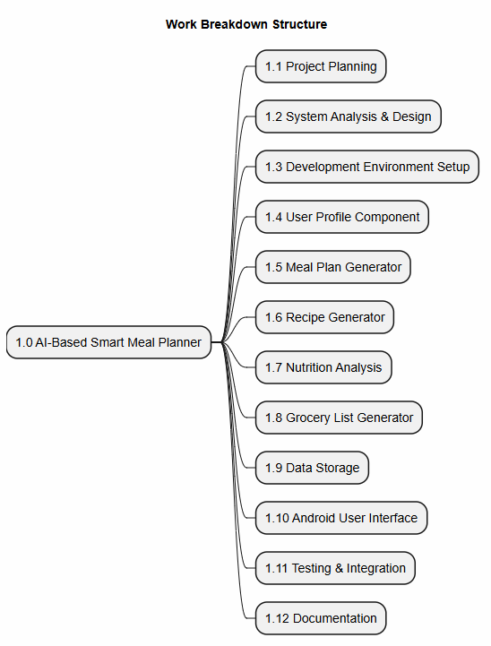

Work Breakdown Structure
WBS ID | Work Package | Description / Major Tasks
1.1 | Project Planning | Objectives, scope, assumptions, constraints, schedule
1.2 | Requirements & System Design | Requirements, UML diagrams, software components
1.3 | Development Environment Setup | Android Studio, Kotlin, GitHub, GenAI API
1.4 | User Profile Component | User profile and preferences
1.5 | Meal Plan Generator | AI meal plan generation
1.6 | Recipe Generator | AI recipe generation
1.7 | Nutrition Analysis | Nutritional analysis
1.8 | Grocery List Generator | Shopping list generation
1.9 | Data Storage | Store and retrieve application data
1.10 | Android User Interface | Android screens and navigation
1.11 | Testing & Integration | Testing and defect fixing
1.12 | Documentation | Final report and project documentation

Delivery Roadmap
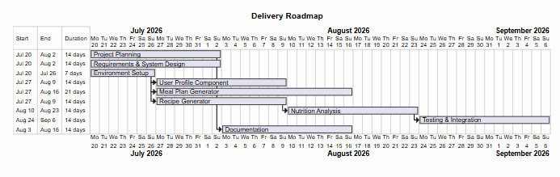
The delivery roadmap outlines the planned timeline for completing the major project milestones throughout the development of the AI-Based Smart Meal Planner. The roadmap provides a high-level schedule of project activities from project planning through to testing and final delivery, ensuring that development tasks are completed in a logical sequence and within the available project timeframe.

Risk Identification and Mitigation Plan
The successful delivery of the AI-Based Smart Meal Planner depends on identifying potential risks that may affect the project's scope, schedule, quality and overall success. The following risk management plan identifies key project risks, assesses their likelihood and impact, and outlines mitigation strategies to reduce their potential effect on project outcomes.

Risk ID | Risk Description | Likelihood | Impact | Mitigation Strategy
R1 | Team member availability or withdrawal may delay project progress. | Medium | High | Maintain regular communication, document project progress and redistribute tasks when required.
R2 | Difficulty integrating the Generative AI API with the Android application. | Medium | High | Prototype the API early, review documentation and allow additional time for troubleshooting and testing.
R3 | AI-generated responses may be inaccurate, inconsistent or fail to satisfy user requirements. | Medium | Medium | Validate AI responses, refine prompts and provide users with the ability to regenerate results.
R4 | Development tasks require more time than originally estimated. | Medium | Medium | Monitor progress regularly, prioritise essential features and adjust the schedule where necessary.
R5 | Technical issues with Android Studio, development tools or third-party services delay development. | Low | Medium | Maintain backups, keep development tools updated and identify alternative solutions where possible.
R6 | Insufficient testing results in application defects before submission. | Medium | High | Conduct regular testing throughout development and perform integration testing before final submission.

Quality Considerations

Team Collaboration

Team Structure

Roles

Responsibilities Matrix

Required Tools and Resources

